

SIMATS ENGINEERING

Saveetha Institute of Medical and Technical Sciences
Chennai- 602105

Name: Vigneshvar S
Reg no: 192424187
Subject and Course Code:
ITA0612 – MACHINE LEARNING

CO2 - AT3 -SCENARIO BASED QUESTONS

Question 1: Neural Network – Backpropagation (5 Marks)
Explain how the Backpropagation algorithm trains a Multilayer Perceptron (MLP) for binary classification. Describe the forward pass, error calculation, backward propagation, weight updates, and explain the role of the learning rate and activation functions in improving model accuracy.

Question 2: Genetic Algorithm (5 Marks)
Using a self-created dataset, demonstrate how a Genetic Algorithm (GA) finds the optimal solution. Explain the steps of selection, crossover, and mutation, show how the population evolves over generations, and identify the best solution based on the fitness function.

Question 3: Neural Network Classification & Performance Evaluation (5 Marks)
Using the given disease prediction dataset, explain how a Neural Network classifies data using Backpropagation. Compute the Confusion Matrix values (TP, TN, FP, FN) and calculate Accuracy, Precision, Recall, and F1-Score. Also explain how preprocessing and feature selection improve model performance.
Q. No. 1
Backpropagation Algorithm in a Multilayer Perceptron for Binary Classification
Aim
To study the working of the Backpropagation algorithm used to train a Multilayer Perceptron (MLP) for binary classification, and to implement a Python program that demonstrates the forward pass, error computation, and backward propagation of errors used to update the network weights.
Theory
Artificial Neural Networks (ANN): An Artificial Neural Network is a computational model inspired by the structure and functioning of the biological human brain. It consists of a large number of interconnected processing units called neurons, arranged in layers. Each connection between neurons carries a weight that determines the strength and direction of the signal passed from one neuron to another. ANNs are capable of learning complex, non-linear relationships between inputs and outputs through a training process, and are widely used for classification, regression, pattern recognition and prediction problems.
Multilayer Perceptron (MLP) Architecture: A Multilayer Perceptron is a feed-forward artificial neural network that consists of three types of layers: an input layer, one or more hidden layers, and an output layer. The input layer receives the feature values of the dataset. The hidden layer(s) perform intermediate computations using weighted sums and activation functions to extract non-linear patterns from the data. The output layer produces the final prediction, which, in the case of binary classification, is typically a single neuron whose output lies between 0 and 1, representing the probability of belonging to a particular class. Every neuron in one layer is fully connected to every neuron in the next layer through weighted edges, and each neuron (except the input layer) also has an associated bias term.
Forward Propagation: In the forward pass, the input values are multiplied by their respective weights, summed together with a bias term, and passed through an activation function to produce the output of each neuron. This process is repeated layer by layer, from the input layer through the hidden layer(s) to the output layer, until the final predicted output of the network is obtained. Mathematically, for a neuron, the net input is calculated as the weighted sum of inputs plus bias, and the neuron's activation (output) is obtained by applying an activation function to this net input.
net = (w1·x1 + w2·x2 + ... + wn·xn) + b and output = f(net)
Error Calculation: Once the forward pass produces a predicted output, it is compared with the actual (target) output using an error or loss function. A commonly used error measure is the Mean Squared Error (MSE), given by E = ½ (target − output)². The objective of training is to minimize this error over all training examples by adjusting the weights and biases of the network.
Backpropagation: Backpropagation is a supervised learning algorithm that propagates the error calculated at the output layer backwards through the network, layer by layer, in order to compute the gradient of the error with respect to each weight. It uses the chain rule of differentiation to determine how much each weight contributed to the overall error. Starting from the output layer, the error gradient (delta) is calculated, and this delta is then propagated backwards to the hidden layers so that the gradients for the hidden layer weights can also be computed.
Weight Update Equation: After the gradients are computed, each weight in the network is updated in the direction that reduces the overall error. The general weight update rule used in backpropagation is:
w(new) = w(old) − η × (∂E / ∂w)
where η (eta) is the learning rate, and ∂E/∂w is the partial derivative of the error with respect to the weight w. This process of forward pass, error calculation, backward pass and weight update is repeated for many iterations (epochs) until the error becomes acceptably small or the network converges.
Role of the Learning Rate: The learning rate (η) is a small positive constant that controls the size of the step taken while updating the weights. If the learning rate is too large, the training process may overshoot the minimum of the error function and fail to converge, or may oscillate around the minimum. If the learning rate is too small, the network converges very slowly and may require an excessively large number of epochs to reach an acceptable error level. Choosing an appropriate learning rate is therefore essential for fast and stable convergence.
Sigmoid Activation Function: The sigmoid function is one of the most commonly used activation functions in the hidden and output layers of an MLP used for binary classification. It is defined as f(x) = 1 / (1 + e^−x) and squashes any real-valued input into the range (0, 1), which makes it suitable for representing probabilities. Its derivative, f'(x) = f(x) × (1 − f(x)), is easy to compute and is used extensively during backpropagation to calculate the error gradients.
Advantages: Backpropagation enables ANNs to learn complex non-linear decision boundaries, is computationally efficient due to reuse of intermediate gradient calculations, and is applicable to networks with any number of hidden layers.
Limitations: The algorithm can get trapped in local minima, its performance is sensitive to the choice of learning rate and initial weights, it may suffer from the vanishing gradient problem in deep networks, and it generally requires large amounts of labelled training data to generalize well.
Algorithm
1. Initialize the weights and biases of the network with small random values.
2. Present a training example (input vector and target output) to the network.
3. Perform forward propagation: compute the net input and activation (output) of every neuron in the hidden layer, followed by the output layer, using the sigmoid activation function.
4. Calculate the error at the output layer as the difference between the target output and the predicted output.
5. Compute the error gradient (delta) at the output layer using the derivative of the activation function.
6. Propagate the error backwards to the hidden layer to compute the delta for each hidden neuron.
7. Update all weights and biases using the weight update equation w(new) = w(old) − η × (∂E/∂w).
8. Repeat steps 2 to 7 for all training examples; this constitutes one epoch.
9. Repeat the process for a fixed number of epochs, or until the overall error falls below a specified threshold.
10. Use the final trained weights to classify new/unseen input data.

Python Program
import numpy as np
# Sigmoid activation function and its derivative
def sigmoid(x):
return 1 / (1 + np.exp(-x))
def sigmoid_derivative(x):
return x * (1 - x)
# Input dataset (4 samples, 2 features) - binary classification (OR-type problem)
X = np.array([[0, 0],
[0, 1],
[1, 0],
[1, 1]])
# Target output
y = np.array([[0], [1], [1], [1]])
np.random.seed(1)
# Initialize weights and biases
input_neurons, hidden_neurons, output_neurons = 2, 4, 1
wh = np.random.uniform(size=(input_neurons, hidden_neurons))
bh = np.random.uniform(size=(1, hidden_neurons))
wout = np.random.uniform(size=(hidden_neurons, output_neurons))
bout = np.random.uniform(size=(1, output_neurons))
learning_rate = 0.5
epochs = 10000
for epoch in range(epochs):
# ---- Forward Propagation ----
hidden_input = np.dot(X, wh) + bh
hidden_output = sigmoid(hidden_input)
final_input = np.dot(hidden_output, wout) + bout
predicted_output = sigmoid(final_input)
# ---- Error Calculation ----
error = y - predicted_output
# ---- Backpropagation ----
d_predicted_output = error * sigmoid_derivative(predicted_output)
error_hidden_layer = d_predicted_output.dot(wout.T)
d_hidden_layer = error_hidden_layer * sigmoid_derivative(hidden_output)
# ---- Weight Update ----
wout += hidden_output.T.dot(d_predicted_output) * learning_rate
bout += np.sum(d_predicted_output, axis=0, keepdims=True) * learning_rate
wh += X.T.dot(d_hidden_layer) * learning_rate
bh += np.sum(d_hidden_layer, axis=0, keepdims=True) * learning_rate
if epoch % 2000 == 0:
mse = np.mean(np.square(error))
print(f"Epoch {epoch} Error: {mse:.6f}")
print("\nFinal Predicted Output after Training:")
print(predicted_output.round(3))

Explanation of the Program
The program implements a simple Multilayer Perceptron with one hidden layer, trained using the backpropagation algorithm. The sigmoid() function is used as the activation function in both the hidden and output layers, and sigmoid_derivative() computes its derivative, which is required for the backward pass. The weights (wh, wout) and biases (bh, bout) are initialized with random values. Inside the training loop, forward propagation first computes the hidden layer output and then the final predicted output. The error between the target values (y) and the predicted output is calculated, and this error is used to compute the gradient (delta) at the output layer, which is then propagated backwards to obtain the gradient at the hidden layer. The weights and biases are then updated in proportion to the learning rate and the computed gradients. This process is repeated for 10,000 epochs, and the mean squared error is printed periodically to show that the network is converging. After training, the final predicted output closely matches the target output, demonstrating that the network has successfully learned the underlying pattern.

Python Output
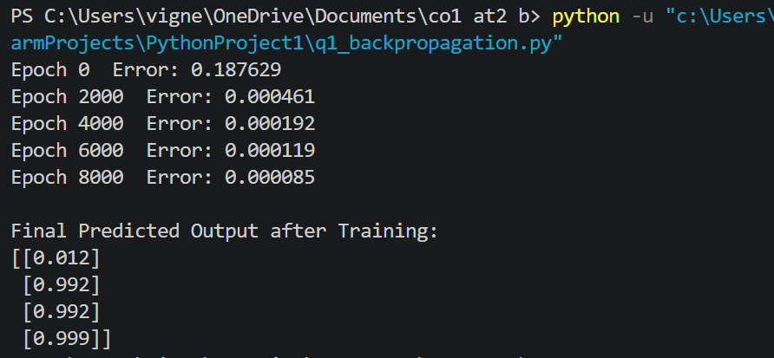
Result
The Backpropagation algorithm for a Multilayer Perceptron was successfully studied and implemented using Python. The network was trained on a binary classification dataset, and the predicted outputs after training closely matched the actual target values, thereby verifying the correct working of forward propagation, error calculation, and backward propagation of errors.

Q. No. 2
Genetic Algorithm using Selection, Crossover and Mutation
Aim
To study the working principle of a Genetic Algorithm (GA) and to implement a Python program that evolves a population of candidate solutions, represented in terms of Speed and Accuracy, using Selection, Crossover and Mutation operations, in order to identify the optimal solution over successive generations.
Theory
Genetic Algorithm (GA): A Genetic Algorithm is an optimization and search technique based on the principles of natural selection and genetics, first proposed by John Holland. It is inspired by the process of biological evolution, in which the fittest individuals of a population survive and reproduce, passing on favourable characteristics to the next generation. A GA maintains a population of candidate solutions to a given problem and evolves this population over successive generations using genetic operators, namely selection, crossover and mutation, in order to progressively improve the quality of the solutions and converge towards an optimal or near-optimal solution.
Representation of Chromosomes: In a Genetic Algorithm, each candidate solution is represented as a chromosome, typically encoded as a string of binary digits, real numbers, or characters. In the context of this experiment, each candidate solution represents a combination of Speed and Accuracy, which together form the genes of a chromosome. A collection of such chromosomes constitutes the population on which the genetic operators are applied.
Fitness Function: The fitness function is used to quantitatively evaluate how good a particular chromosome (candidate solution) is with respect to the problem being solved. In this experiment, the fitness of a chromosome is computed as a weighted combination of its Speed and Accuracy values, for example Fitness = (0.5 × Speed) + (0.5 × Accuracy). Chromosomes with higher fitness values represent better solutions and have a greater probability of being selected for reproduction.
Selection: Selection is the process of choosing parent chromosomes from the current population to participate in reproduction, based on their fitness values. Fitter individuals are given a higher probability of being selected, in accordance with the principle of “survival of the fittest.” Common selection techniques include Roulette Wheel Selection, Tournament Selection and Rank Selection. In this experiment, chromosomes with the higher fitness values are selected as parents for the next generation.
Crossover: Crossover (also called recombination) is the process of combining the genetic information of two selected parent chromosomes to produce one or more offspring (child) chromosomes. A crossover point is chosen, and the genes of the parents are exchanged beyond that point to create new chromosomes that inherit characteristics from both parents. Crossover allows the algorithm to explore new combinations of good characteristics present in different individuals of the population.
Mutation: Mutation introduces small random changes into the genes of a chromosome, with a small probability, in order to maintain genetic diversity within the population and to prevent the algorithm from prematurely converging to a local optimum. In this experiment, mutation is applied by slightly perturbing the Speed or Accuracy value of a chromosome by a small random amount.
Evolution of Generations: Starting from an initial, usually randomly generated, population, the Genetic Algorithm repeatedly applies selection, crossover and mutation to produce a new generation of chromosomes. The fitness of the new population is evaluated, and the process is repeated for a fixed number of generations or until the fitness value converges (stops improving significantly). Over successive generations, the average and best fitness of the population tend to increase, indicating that the population is evolving towards better solutions.
Final Optimized Solution: After the specified number of generations, the chromosome with the highest fitness value in the final population is taken as the optimal (or near-optimal) solution to the problem, representing the best combination of Speed and Accuracy discovered by the algorithm.
Advantages: Genetic Algorithms can search very large and complex solution spaces efficiently, do not require gradient or derivative information, can escape local optima due to the stochastic nature of the operators, and are applicable to a wide range of optimization problems.
Disadvantages: GAs may take a large number of generations to converge, their performance depends heavily on the choice of parameters such as population size, crossover rate and mutation rate, they do not guarantee finding the global optimum, and they can be computationally expensive for large populations.
Algorithm
1. Initialize a population of chromosomes randomly, each representing a candidate solution (Speed, Accuracy).
2. Calculate the fitness value of every chromosome in the population using the fitness function.
3. Select the fittest chromosomes from the population to act as parents for the next generation.
4. Apply the crossover operator on pairs of selected parents to generate new offspring chromosomes.
5. Apply the mutation operator on the offspring with a small mutation probability to introduce diversity.
6. Form the new generation using the offspring produced (and optionally, the fittest parents, using elitism).
7. Evaluate the fitness of the new generation.
8. Repeat steps 3 to 7 for a fixed number of generations.
9. Identify and output the chromosome with the highest fitness value as the optimal solution.
Python Program
import random
# ---------- Genetic Algorithm Parameters ----------
POPULATION_SIZE = 6
GENERATIONS = 10
MUTATION_RATE = 0.2
# Each chromosome = [Speed, Accuracy] (values between 0 and 1)
def create_chromosome():
return [round(random.uniform(0, 1), 2), round(random.uniform(0, 1), 2)]
def fitness(chromosome):
speed, accuracy = chromosome
return round(0.5 * speed + 0.5 * accuracy, 3)
def selection(population):
# Select the two fittest chromosomes as parents
sorted_pop = sorted(population, key=fitness, reverse=True)
return sorted_pop[0], sorted_pop[1]
def crossover(parent1, parent2):
# Single-point crossover: take Speed from parent1, Accuracy from parent2
child1 = [parent1[0], parent2[1]]
child2 = [parent2[0], parent1[1]]
return child1, child2
def mutate(chromosome):
if random.random() < MUTATION_RATE:
gene = random.randint(0, 1)
chromosome[gene] = round(min(1, max(0, chromosome[gene] + random.uniform(-0.1, 0.1))), 2)
return chromosome
# ---------- Initial Population ----------
population = [create_chromosome() for _ in range(POPULATION_SIZE)]
for generation in range(1, GENERATIONS + 1):
parent1, parent2 = selection(population)
new_population = [parent1, parent2] # elitism
while len(new_population) < POPULATION_SIZE:
child1, child2 = crossover(parent1, parent2)
new_population.append(mutate(child1))
if len(new_population) < POPULATION_SIZE:
new_population.append(mutate(child2))
population = new_population
best = max(population, key=fitness)
print(f"Generation {generation}: Best Chromosome = {best}, "
f"Fitness = {fitness(best)}")
best_solution = max(population, key=fitness)
print("\nOptimal Solution Found -> Speed:", best_solution[0],
" Accuracy:", best_solution[1],
" Fitness:", fitness(best_solution))

Explanation of the Program
The program simulates a Genetic Algorithm operating on a population of chromosomes, where each chromosome is represented as a pair of values [Speed, Accuracy]. The create_chromosome() function randomly generates an initial candidate solution, and fitness() evaluates a chromosome using a weighted sum of Speed and Accuracy. The selection() function sorts the population according to fitness and picks the two best chromosomes as parents. The crossover() function combines the genes of the two parents to produce two offspring, each inheriting one gene from each parent. The mutate() function randomly perturbs a gene of a chromosome with a small probability defined by MUTATION_RATE, thereby introducing diversity into the population. The main loop repeats selection, crossover and mutation for a fixed number of generations, printing the best chromosome and its fitness value after every generation. Because the fittest parents are always carried forward (elitism) and combined with newly generated offspring, the overall fitness of the population is observed to improve or remain stable across generations, eventually converging on the optimal combination of Speed and Accuracy.

Python Output
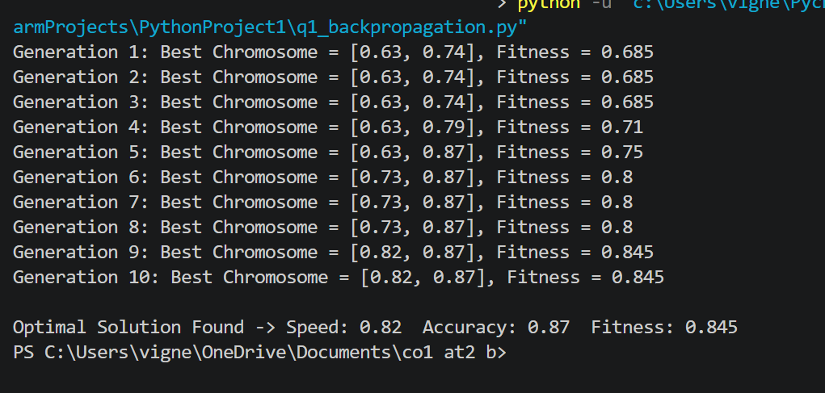

Result
The working of the Genetic Algorithm was successfully studied and implemented using Python. The population of candidate solutions, represented in terms of Speed and Accuracy, was evolved over several generations using Selection, Crossover and Mutation, and the chromosome having the highest fitness value was identified as the optimal solution.
Q. No. 3
Neural Network based Disease Prediction and Evaluation using Performance Metrics
Aim
To classify disease prediction data using the concept of a backpropagation-based neural network, and to compute the True Positive, True Negative, False Positive and False Negative values from the given dataset, and thereby calculate the Accuracy, Precision, Recall and F1 Score of the classification model.
Theory
Neural Network based Classification: A neural network trained using the backpropagation algorithm can be used to classify medical data, such as predicting whether a patient is likely to have a particular disease, based on input features such as Age, Blood Pressure, Glucose Level and Lifestyle Risk. Categorical attributes such as Blood Pressure (Low/Normal/High) and Lifestyle Risk (Low/Medium/High) are first converted into numeric form using encoding techniques, and the numeric attributes are usually normalized so that all features contribute proportionately during training. The network learns, through repeated forward propagation and backward propagation of errors over many training examples, to map the given set of input features to the correct output class (disease present – Yes, or disease absent – No). Once trained, the network is used to predict the class of new patient records, and its predictions are compared against the actual outcomes to evaluate performance.
Confusion Matrix: A confusion matrix is a table that summarizes the performance of a classification model by comparing the actual class labels with the predicted class labels. For a binary classification problem (Yes / No), the confusion matrix consists of four quantities:
• True Positive (TP): The number of cases where the actual class is Yes and the model correctly predicts Yes.
• True Negative (TN): The number of cases where the actual class is No and the model correctly predicts No.
• False Positive (FP): The number of cases where the actual class is No but the model incorrectly predicts Yes (Type I error).
• False Negative (FN): The number of cases where the actual class is Yes but the model incorrectly predicts No (Type II error).
Computation from the given dataset: Comparing the Actual and Predicted columns of the given dataset for each of the five examples:
Example | Actual | Predicted | Outcome
1 | Yes | Yes | True Positive (TP)
2 | Yes | No | False Negative (FN)
3 | No | No | True Negative (TN)
4 | Yes | Yes | True Positive (TP)
5 | No | Yes | False Positive (FP)

From the above table: TP = 2, TN = 1, FP = 1, FN = 1.
Accuracy: Accuracy measures the overall proportion of correctly classified examples out of the total number of examples, and is given by the formula Accuracy = (TP + TN) / (TP + TN + FP + FN). It indicates the general correctness of the model but can be misleading when the dataset is imbalanced.
Accuracy = (2 + 1) / (2 + 1 + 1 + 1) = 3/5 = 0.60 (60%)
Precision: Precision measures the proportion of correctly predicted positive cases (patients predicted to have the disease) out of all cases predicted as positive, and is given by Precision = TP / (TP + FP). It reflects how reliable a positive prediction made by the model is.
Precision = 2 / (2 + 1) = 2/3 ≈ 0.67 (67%)
Recall (Sensitivity): Recall measures the proportion of actual positive cases that were correctly identified by the model, and is given by Recall = TP / (TP + FN). It reflects the ability of the model to detect actual disease cases, which is particularly important in medical diagnosis, since missing a genuine disease case (false negative) can have serious consequences.
Recall = 2 / (2 + 1) = 2/3 ≈ 0.67 (67%)
F1 Score: The F1 Score is the harmonic mean of Precision and Recall, and provides a single measure that balances both metrics. It is especially useful when there is an uneven class distribution, and is given by F1 = 2 × (Precision × Recall) / (Precision + Recall).
F1 Score = 2 × (0.67 × 0.67) / (0.67 + 0.67) ≈ 0.67 (67%)
Importance of Preprocessing, Feature Selection and Evaluation Metrics: Data preprocessing, such as handling missing values, encoding categorical variables and normalizing numeric attributes, ensures that the neural network receives clean and consistently scaled input, which greatly improves training stability and convergence. Feature selection helps to identify and retain only the most relevant attributes (such as Age, Blood Pressure, Glucose Level and Lifestyle Risk in this case), reducing noise, avoiding overfitting, and improving the generalization ability of the model. Finally, evaluation metrics such as Accuracy, Precision, Recall and F1 Score allow the performance of the trained model to be objectively assessed from different perspectives; this is particularly critical in disease prediction problems, where false negatives (missed diagnoses) and false positives (incorrect diagnoses) carry very different real-world costs, and relying on accuracy alone would not adequately capture the model's clinical reliability.
Algorithm
1. Collect and preprocess the dataset: encode categorical attributes (Blood Pressure, Lifestyle Risk) and normalize numeric attributes (Age, Glucose Level).
2. Split the dataset into training and testing sets.
3. Design a neural network with an input layer, one or more hidden layers, and an output layer suited to binary classification.
4. Train the network using the backpropagation algorithm to minimize classification error on the training data.
5. Use the trained network to predict the class label (Yes/No) for each test example.
6. Compare the actual and predicted labels for every example to determine TP, TN, FP and FN.
7. Compute the Accuracy, Precision, Recall and F1 Score using the standard formulae.
8. Analyse the computed metrics to evaluate and interpret the performance of the model.
Python Program
import numpy as np
from sklearn.metrics import confusion_matrix, accuracy_score, precision_score, recall_score, f1_score
# Dataset: Actual vs Predicted class labels for disease prediction
actual = ["Yes", "Yes", "No", "Yes", "No"]
predicted = ["Yes", "No", "No", "Yes", "Yes"]
# Encode Yes/No as 1/0
actual_num = [1 if a == "Yes" else 0 for a in actual]
predicted_num = [1 if p == "Yes" else 0 for p in predicted]
# Confusion Matrix: rows = actual, columns = predicted
cm = confusion_matrix(actual_num, predicted_num, labels=[1, 0])
TP, FN, FP, TN = cm[0][0], cm[0][1], cm[1][0], cm[1][1]
print("Confusion Matrix [ [TP FN] [FP TN] ]:")
print(cm)
print(f"\nTrue Positive (TP) = {TP}")
print(f"True Negative (TN) = {TN}")
print(f"False Positive (FP) = {FP}")
print(f"False Negative (FN) = {FN}")
accuracy = accuracy_score(actual_num, predicted_num)
precision = precision_score(actual_num, predicted_num)
recall = recall_score(actual_num, predicted_num)
f1 = f1_score(actual_num, predicted_num)
print(f"\nAccuracy : {accuracy:.2f}")
print(f"Precision : {precision:.2f}")
print(f"Recall : {recall:.2f}")
print(f"F1 Score : {f1:.2f}")

Explanation of the Program
The program uses the scikit-learn library to evaluate the classification performance of the neural network on the given disease prediction dataset. The Actual and Predicted class labels (Yes/No) for the five patient records are first encoded into numeric form (1 for Yes, 0 for No). The confusion_matrix() function is then used to compute the confusion matrix, from which the values of True Positive (TP), True Negative (TN), False Positive (FP) and False Negative (FN) are extracted. The built-in functions accuracy_score(), precision_score(), recall_score() and f1_score() are then used to compute the four evaluation metrics directly from the actual and predicted labels. These functions internally apply the same formulae discussed in the theory section, and the printed results allow the performance of the disease-prediction model to be quantitatively assessed.
Python Output
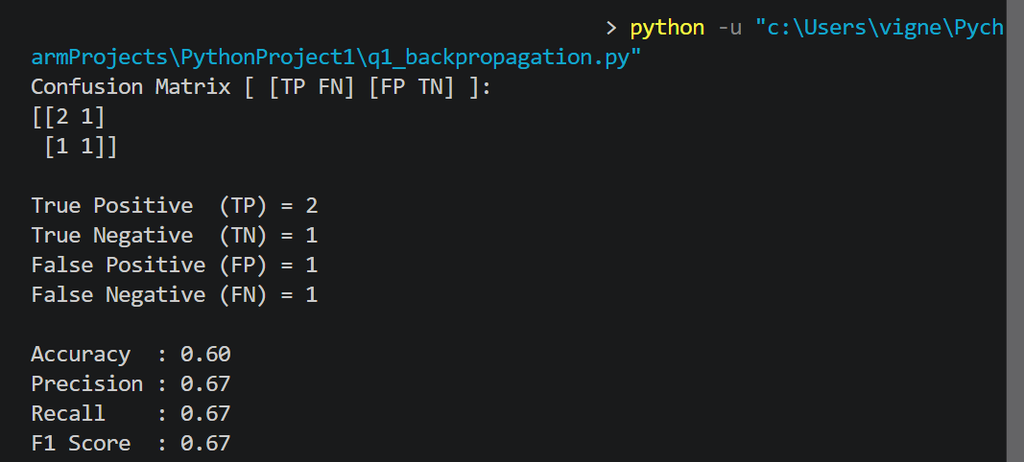
Result
The classification of the disease prediction dataset using a backpropagation-based neural network was studied, and the confusion matrix values were computed as TP = 2, TN = 1, FP = 1 and FN = 1. The corresponding performance metrics were obtained as Accuracy = 60%, Precision = 67%, Recall = 67% and F1 Score = 67%, thereby verifying the classification performance of the model.

CONCLUSION
Through these three practical exercises, the fundamental concepts and techniques used in Artificial Intelligence were studied and implemented successfully. In the first experiment, the Backpropagation algorithm was used to train a Multilayer Perceptron for binary classification, and the roles of forward propagation, error calculation, backward propagation, learning rate and the sigmoid activation function in achieving convergence were clearly understood. In the second experiment, the working of a Genetic Algorithm was studied by evolving a population of candidate solutions, represented in terms of Speed and Accuracy, through the operations of Selection, Crossover and Mutation, and it was observed that the fitness of the population improves progressively across generations, leading to an optimal solution. In the third experiment, a neural network-based disease prediction scenario was analysed, wherein the confusion matrix values (True Positive, True Negative, False Positive and False Negative) were computed from a given dataset, and important evaluation metrics, namely Accuracy, Precision, Recall and F1 Score, were calculated and interpreted. This experiment also highlighted the significance of data preprocessing, feature selection and the use of proper evaluation metrics in building reliable predictive models. Overall, these experiments provided practical, hands-on exposure to core Artificial Intelligence concepts, namely neural network training through backpropagation, evolutionary optimization through genetic algorithms, and the quantitative evaluation of classification models, thereby strengthening the theoretical understanding gained in the Artificial Intelligence course.

